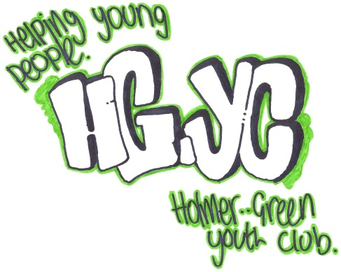
HOLMER GREEN YOUTH CLUB
18 Parish Piece
Holmer Green
High Wycombe
Buckinghamshire
HP15 6SW
Email: holmergreenyc@gmail.com
Tel No: 07907 343110
WEBSITE - www.holmergreenyouthclub.org.uk

Established in Holmer Green since 1966 – Registered Charity No. 300293
Registered Address: Holmer Green Youth Club, 18 Parish Piece, Holmer Green, High Wycombe, Buckinghamshire, HP15 6SW

Affiliated to: Action4Youth

Logo Designed By: George Rayment

Dear Parents and Guardians
Year 6 sessions
I am pleased to announce the start of a session for Year 6 at Holmer Green Youth Club.
It will take place on:

Monday evenings, 6.30-7.30pm.

Starting: Monday 4th October 2021 at 6.30pm

Cost: £2.00 per session. We will be offering a way of paying £22 per term direct into our bank account from January. This offers 3.5 free sessions per year. You will receive an e-mail beforehand with details on this or you can still pay cash each week.

We have pool tables, air hockey, a table tennis table, PlayStation 4, and table football. There is an outdoor area with seating and games area for the better weather. Sweets and drinks are sold on the night.

The club will be staffed by a qualified youth worker and teenage helpers. I will be in charge of the session.

If your child would like to come, please print and fill out the membership form on our website www.holmergreenyouthclub.org.uk under downloads and bring it to the first session. Hard copies are also available at the school and at the Youth Club. If your child wants to bring a friend of the same age, they should just come along and we will take the details.

Covid measures
Please be assured all appropriate measures are in place.

Picking up
Please come to the Youth Club car park. We don’t like allowing young people of this age to leave the premises without an adult present.

If you have any questions then please feel free to email me on the email address above.
Thank You

Michael Turner
Managing Youth Worker

