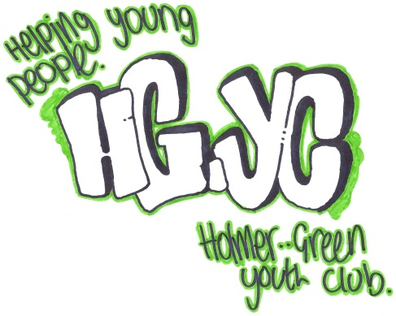
HOLMER GREEN YOUTH CLUB
Parish Piece
Holmer Green
High Wycombe
Buckinghamshire
HP15 6SW
01494 718404
Email: holmergreenyc@gmail.com

WEBSITE - www.holmergreenyouthclub.org.uk

Established in Holmer Green since 1966 – Registered Charity No. 300293
Registered Address: 18 Holmer Green Youth Club, Parish Piece, Holmer Green, High Wycombe, Buckinghamshire, HP15 6SW

Logo Designed By: George Rayment

I am very sorry but this year group has a waiting list. If you would like to go on this list and for me to contact you when a space becomes available please can you e-mail Holmer Green Youth Club on the e-mail address above with -
- Young Person’s Name
- E-mail address
- With the E-mail saying you give HGYC permission to hold this information until asked to remove.

Mike Turner
Managing Youth leader
Holmer green Youth Club

